Arc GIS online App builder
Materials at GISetc.com/geoed19
Roger Palmer
8:00 Introductions
8:15 Engage: Intro to ArcGIS online platform:
ArcGIS progression, its purpose, its audience
Part of the virtualization movement: Gmail, Google Docs, Office 365, shopping, friendships,
news , opinions, dating, competitions (gaming)
How is this GIS system like…
Dropbox, wikepedia, prezi, amazon, social media, linkedin, kahn academy, mini cooper,
…
8:30 Explore: What are map applications?
Before using app builder to design a custom App let’s start exploring several apps to see how they limit the arcgis online experience. We’ll start on the Gallery of web apps to see how some of the highlighted applications engage their users.
https://www.arcgis.com/apps/MapAndAppGallery/index.html?appid=1e3085af6e1a48c8908fa624bdfef768
- Search for the Ag Imagery Feedback app by searching for “NAIP”
What is the purpose of this app and what tools are included?

- App builder gives you the ability to custom design the arcgis map interface to accomplish only what you want for a select user group. It essentially allows you to limit your audience to do the one or two things related to the purpose of you or your client. If you are a city, you might mainly want a directory for people to explore businesses. Search the app gallery “Whereto”: http://whereto.sg click on the pin near the right side and click somewhere on the map. Try the left and right drag on the map to see how it moves.
Do these tools look standard to arcgis online?

- Next let us visit an example of a city’s trail maps. In the search tool, just search for the City’s name of “Groton” or click here: http://maps.groton-ct.gov/apps/HikingTrails/

See if you can zoom into Haley Park (click on it in the trail Table) and add your own favorite trail around Fitch Senior high.

In the draw tool area there is an elevation tool. Much like the draw, follow a trail in the area after clicking the tool to click your way through a local trail. Double click to end the drawing to see the elevation changes. Cancel or x out of the Groton Trails legend and find out what information you can on who can use the Haley farm trail.
What are the only activities not allowed in the park?
Roughly how many miles is the longest cross country ski run in town?
- For a particularly clean App, search for “Portland By Bicycle”.
How does it work for it’s users?
9:00 Break
9:10 Explain: To create your own apps, you will need to be logged in to arcgis.com,
Normally you would build an app around some map you have created.
The pathway to building an app that I encourage for students or those new to GIS is to:

Maps that work well for app builder start with only a few layers and tools, like the Portland bike map. Choose those you suspect have an influence on each other or a perhaps a single layer that contains easy to graph information for instance: measurements over time (populations, concentrations, costs or income.)
Apps are designed to limit the number of tools with which to interact in order to focus the user to a more streamlined experience. So the design really starts at the map in the arcgisonline viewer. If you want the user to have the full experience with all the data and tools, use the viewer. If not, read on! You may have maps you are dying to put into an applications, but I find using finished maps helps those new to making apps focus on the app design process and get away from worrying about coming up with a good map. We will use the series of maps called Geoinquiries. While they are posted at esriurl.com/geoinquiries on the esri site, we will use the following link for a graphically more organized collection:
- Https://GISetc.com/geoinquiries lists the links for the map directly. Scroll to the bottom of the page and Click on the Map Layer Links by collection to open the pdf. You can scroll to page 13 in the pdf or search the document for “Landforms”. [Ctrl + f]
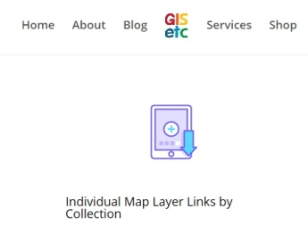
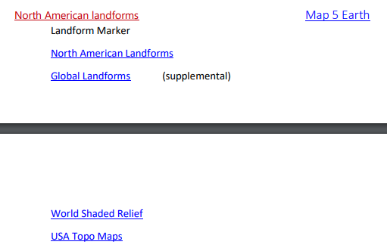

- Click on the Map 5 Earth link and once the map opens, login to your arcGIS online account. (Use the ones listed on your computer.)
- Save a copy of the landforms map with your name: Landforms_RogerPalmer and provide some level of metadata about your version of this map.
- Click to Share your map and choose to make a web application.
The middle tab allows you to choose your own customizable application. Fill in the basic metadata about the application you are making which will be saved as a web mapping application in your content folder.
9:30 Elaborate: Customizing your application.
Choose a template: To start, the templates are all very similar in how they work, so once comfortable it becomes easy to transfer your understanding to these interfaces. For the first few projects, lets choose the default. You will see only a few widgets are included but it gives you space to choose up to 5 others to add to the interface.
Configuring your applications widgets: You will be creating an app that allows students to both be exposed to common landforms and draw around them to make sure they understand what different landforms are called.

Click the numbered widget holders at the bottom of the page to add the Draw tool, the Bookmark tool, and the Base map changer
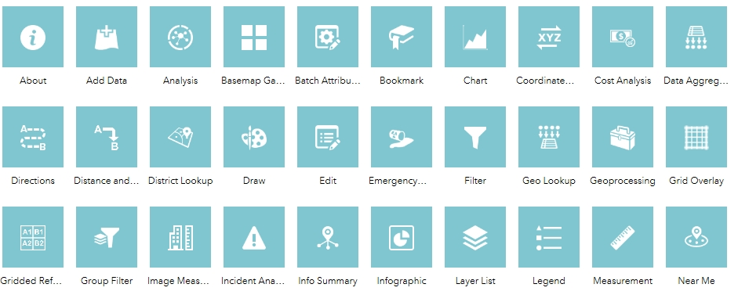

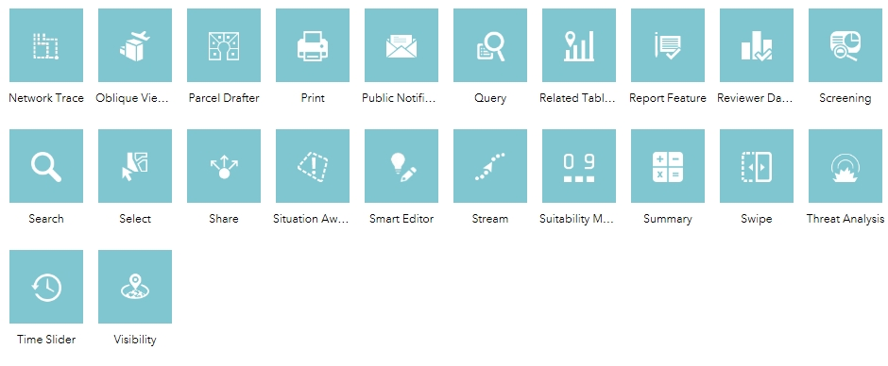

View your app in a few of the possibly different hardware devices that might access your widget. Then launch your app to see if it performs like you want it to. You can always go back to configure it differently .
10:00 Break

10:15 Evaluate: Make a couple more applications from maps in the geoinquiry series.
- Building your next app: Analysis
This time let’s use the list of maps at GISetc.com/geoinquiries to find “A River” & open the map.
Save it with your name at the end and choose to share it as a web application>web app builder.
Add the drawing tool to highlight water sheds and an analysis tool to create watersheds and trace downstream. For extra credit create two separate analysis tools.

- Try an Elementary “Energy Production” map , sign in, save with your name, and share as app.
Add the analysis tool and use summarize to find the total power produced per state.

- Build your own map! Search for and add “States” (generalized). Save it with your name and share it to make an application.
Add the chart tool and the info graphic tool to compare their look. Use a pie graph in the chart tool comparing state ethnicities. In the infographic compare the age cohorts as bar charts.
10:50 Show off any finished products you’ve created! Screenshot pictures to #geoed19

